MACHINE LEARNING (ECE 6397)

Analysis of GAN generated Images for Classification of Leaves using CNN

Project Members:

**Aditi Singh**

**Gaurav Roy**

**Rachel Mills**

**Raj Shah**

Xiaoyang Li

# **Abstract**

The purpose of this project is to analyze the efficiency of a Generative Adversarial Network (GAN) in generating images that are similar to the ones provided during training. Gathering or assembling a dataset for supervised and unsupervised learning is a very big challenge especially in the domain of computer vision and image classification. The GAN generates images based on a training dataset which are later used for validation of a Convolutional Neural Network (CNN) which is also trained on the same dataset.

**Table of Contents**

Abstract 2

List of Figures 4

List of Tables 5

Introduction 6

Motivation and Literature Review 7

Need for Automated Generation of Dataset 7

Prior Work on classification of tree genus 7

Overview 8

Generative Adverserial Networks 8

Discriminative vs Generative models 8

GAN Intuition 8

Theoretical Results of Training. 10

GAN Used to Generate Leaves for Classification. 12

Generator and Discriminator Architecture 13

Convolutional Neural Networks 17

Methodology 21

Dataset 21

Preprocessing 22

GAN – Training and Validation 23

D-Loss and G-Loss for Images with veins 23

D-Loss and G-Loss with borders 24

CNN – Training and Validation 24

Results and Conclusion 25

Results of GAN 25

Results of CNN 28

Future Work 29

References 30

# **List of Figures**

Figure 1. Block Diagram of Generative Adversarial Networks 9

Figure 2. Probabilistic Model 10

Figure 3. Training of GAN 11

Figure 4. Generator Architecture 11

Figure 5. Discriminator Architecture 12

Figure 6. . Input Dataset with Target 13

Figure 7. Generator trying to get colorize output 13

Figure 8.The discriminator is looking at the generator's colorization attempts and trying to learn to tell the difference between the colorizations the generator provides, and the true colorized target image provided in the dataset. 13

Figure 9. Encoder-Decoder Structure 14

Figure 10. Encode-Decode Operation 14

Figure 11. U-net structure with skip Connections 15

Figure 12. Discriminator Structure 15

Figure 13. Discriminator Training 16

Figure 14.Generator Training 16

Figure 15. A simple ConvNet. 17

Figure 16. the ReLU operation 19

Figure 17. ReLU operation. 19

Figure 18. Max Pooling 20

Figure 19. Flow chart of image preprocessing 22

Figure 20. Graph of GAN architecture (generated from tensorboard) 23

Figure 21. Step 23

Figure 22. Wall 23

Figure 23. Step 24

Figure 24. Wall 24

Figure 25. Alexnet Architecture 24

Figure 26. Maple, Magnolia, Pine, Elm, Oak leaves (left to right) 25

Figure 27. Sample of reconstructed border and vein images (left to right) 25

Figure 28. Elm 26

Figure 29. Magnolia 26

Figure 30. Oak 27

Figure 31. Maple 27

Figure 32. Pine 28

# **List of Tables**

Table 1. Convolution filters and their respective outputs 18

Table 2. Description of dataset 21

Table 3. CNN Analysis 28

Table 4. Confusion Matrix for vein reconstructed images 28

Table 5. Confusion Matrix for border reconstructed images 29

# **Introduction**

In this paper we address the classification of trees given a sketch of a leaf. From foresters, to gardeners, and even the average individual, classifying trees can be an important task. Trees give sources for fuel and other amenities such as lumber, and even a source of nutrients. The goal of tree classification encompases many aspects, from elementary education to running economies. Ideally, this project will extend to the identification and classification of many more species.

*Current Methods to classify trees:*

Trees can be visually classified by overall appearance: bark, wood toughness, flowers, and leaves. However, the difference in tree bark does not vary extensively between trees, wood toughness is difficult to evaluate, and depending on the season, the tree may or may not have flowers. One consistent way to classify trees is by their leaves, regardless of the age or season of the tree, the leaf structure remains unchanged. A simple sketch of a leaf assists in identifying one tree from another. In this project, five genera of trees are selected: Maple, Elm, Oak, Magnolia, and Pine. Within each genus, several species are selected that represent the average leaf form of each genus.

**Table 1. Description of leaf species used**

|  |  |
| --- | --- |
| **Genus** - Common Name | **Species** |
| Elm | *Ulmus americana, Ulmus glabra, Ulmus parvifolia, Ulmus procera, Ulmus pumila, Ulmus rubra* |
| Magnolia | *Magnolia acuminata,Magnolia denudata, Magnolia grandiflora, Magnolia macrophylla, Magnolia soulangiana, Magnolia stellata, Magnolia tripetala, Magnolia virginiana* |
| Maple | *Acer negundo, Acer palmatum, Acer pseudoplatanus, Acer rubrum, Acer saccharinum, Acer saccharum* |
| Oak | *Quercus alba, Quercus cerris, Quercus coccinea, Quercus macrocarpa, Quercus palustris, Quercus rubra, Quercus shumardii, Quercus stellata, Quercus velutina* |
| Pine | *Pinus densiflora, Pinus koraiensis, Pinus parviflora, Pinus pungens, Pinus rigida, Pinus sylvestris, Pinus thunbergii, Pinus virginiana, Pinus wallichiana* |

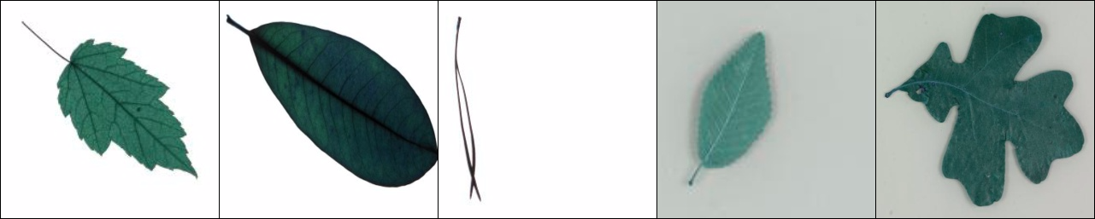

*Figure 1: Maple, Magnolia, Pine, Elm, Oak leaves (left to right)*

# **Motivation and Literature Review**

## **Need for Automated Generation of Dataset**

Image databases are an essential element of object recognition research. They are required for learning visual object models and for testing the performance of classification, detection, and localization algorithms. In fact, publicly available image collections such as UIUC, Caltech 4, and Caltech 101 have played a key role in the recent resurgence of category-level recognition research, driving the field by providing a common ground for algorithm development and evaluation. Current datasets, however, offer a somewhat limited range of image variability: Although the appearance (and to some extent, the shape) of objects does indeed vary within each class (e.g., among the airplanes, cars, faces, and motorbikes of Caltech 4), the viewpoints and orientations of different instances in each category tend to be similar (e.g., side views of cars taken by a horizontal camera in UIUC); their sizes and image positions are normalized (e.g., the objects of interest take up most of the image and are approximately centered in Caltech 101); there is only one instance of an object per image; finally, there is little or no occlusion and background clutter.

The problems with such restrictions are twofold: (i) some algorithms may exploit them (for example near-global descriptors with no scale or rotation invariance may perform well on such images), yet will fail when the restrictions do not apply; and, related to this, (ii) the images are not sufficiently challenging for the benefits of more sophisticated algorithms (e.g., scale invariance) to make a difference. This means that progress in algorithm capability cannot be assessed.

## **Prior Work on classification of tree genus**

Traditionally, tree classification is accomplished by means of extensive manuals and field guides.  More recently, machine learning has assisted this difficult task of identifying tree species. As diverse forest species are becoming extinct, a database of plant life an urgent need. Supervised learning is key to this much needed classification task; during this process, outputs are inferred from labeled training data.  Prior work utilises nearest neighbour algorithms of leaf curvature to retrieve the most similar leaf match (Kumar et al., 2012). In this process, the nearest vertex is visited in the domain until all vertices have been explored. As it is updated with a greedy nature, there is a potential to miss shorter paths; thus, nearest neighbours does not guarantee an optimal result, additionally, it may not find an optimal solution at all.

Advanced methods based on nearest neighbours include Moving Median Centers (MMC) Hypersphere Classifier and Supervised Locality Projection Analysis (SLPA) to cope with shortcomings, especially when leaf significant contour features are difficult to find.  MCC hypersphere resulted in saving storage space along with reducing the classification time without sacrificing accuracy.  Fundamentally, each class of patterns is set as a series of hyperspheres and is regarded as a set of points.  Initially, a class is set as the multidimensional median of the point, and the maximum radius surrounding the class is calculated.  Iterations extend the hypersphere to include the greatest number of points, once this is achieved, all the points within are removed and the process is repeated for the class (Du  et al., 2007). Classification is executed using nearest neighbour to each hypersphere. Newer papers propose the use of SLPA, which in theory, mimics pairwise interactions between nodes.  Its goal is to judge if pairwise points belong to the same class when computing the weight of edges (Zhang et al, 2013). In this algorithm, each node portrays a label and simultaneously receives depicted labels of neighbouring nodes; at each broadcasting of labels, each node acquires a memory of its nearest neighbour.  A weight calculation is subsequently calculated to judge if any two points have the same label, thus aiding in the discrimination between classes.

# **Overview**

## **Generative Adverserial Networks**

### Discriminative vs Generative models

A **discriminative** model learns a function that maps the input data (*x*) to some desired output class label (*y*). In probabilistic terms, they directly learn the conditional distribution *P(y|x)*.

A **generative** model tries to learn the joint probability of the input data and labels simultaneously, i.e. *P(x,y)*. This can be converted to *P(y|x)* for classification via Bayes rule, but the generative ability could be used for something else as well, such as creating likely new *(x, y)* samples.

### GAN Intuition

GAN has two neural networks which compete against each other: A **generator** network G(z), and a **discriminator** network D(x).

The generator tries to mimic examples from a training dataset, which is sampled from the true data distribution q(x). It does so by transforming a random source of noise received as input into a synthetic sample.

The discriminator receives a sample, but it is not told where the sample comes from. Its job is to predict whether it is a data sample or a synthetic sample.

The discriminator is trained to make accurate predictions, and the generator is trained to output samples that fool the discriminator into thinking they came from the data distribution.

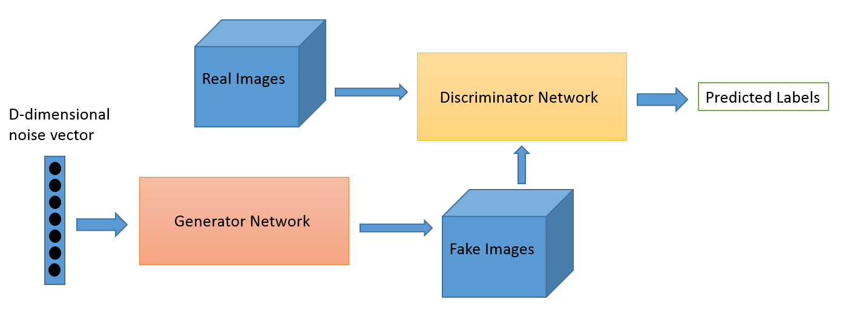

**Figure 1. Block Diagram of Generative Adversarial Networks**

Fig. 1 Block Diagram of General Adversarial Networks

To better understand GANs, it is necessary to describe it using a probabilistic framework. Two marginal distributions are defined:

* the *data* marginal q(x), and
* the *model* marginal p(x)=∫p(z)p(x∣z)dz.

The generator operates by sampling z∼p(z) and then sampling x∼p(x∣z). The discriminator receives either the generator sample, x∼p(x∣z) or x∼q(x) and outputs the probability that its input was sampled from q(x).

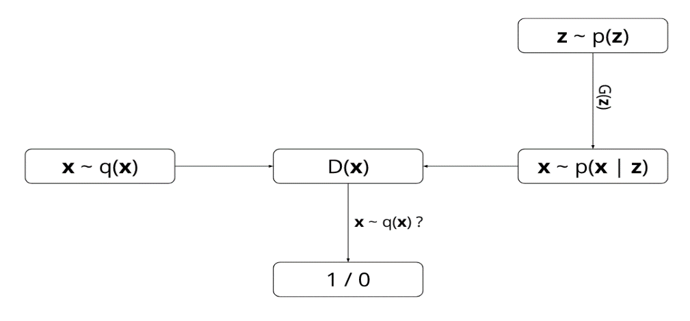

**Figure 2. Probabilistic Model**

To learn the generator’s distribution over data x, we define a prior on input noise variables p(z), then represent a mapping to data space as G(z), where G is a differentiable function represented by a multilayer perceptron. We also define a second multilayer perceptron D(x) that outputs a single scalar. D(x) represents the probability that x came from the data rather than p(x|z). We train D to maximize the probability of assigning the correct label to both training examples and samples from G. We simultaneously train G to minimize log(1 − D(G(z))). In other words, D and G play the following two-player minimax game with value function V (G, D):

$$\min_{G}{\max_{D}{V(D, G)}}=Eq\left(x\right)\left[\log\left(D\left(x\right)\right)\right]+Ep\left(z\right)[\log\left(1-D\left(G\left(z\right)\right)\right)]$$

$$\min_{G}{\max_{D}{V\left(D, G\right)}}= \int{q\left(x\right)\log\left(D\left(x\right)\right)}dx + \iint{p\left(z\right)p(x|z)log⁡(1-D\left(x\right))dxdz}$$

### Theoretical Results of Training.

On one hand, the discriminator is trained to maximize the probability of correctly classifying data samples and synthetic samples. On the other hand, the generator is trained to produce samples that fool the discriminator, i.e. that are unlikely to be synthetic according to the discriminator.

It can be shown that for a fixed generator, the optimal discriminator is

D∗(x)= q(x)/q(x)+p(x)

and that given an optimal discriminator, minimizing the value function with respect to the generator parameters is equivalent to minimizing the Jensen-Shannon divergence between p(x) and q(x).

In other words, as training progresses, the generator produces synthetic samples that look more like the training data.

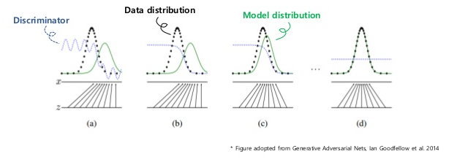

**Figure 3. Training of GAN**

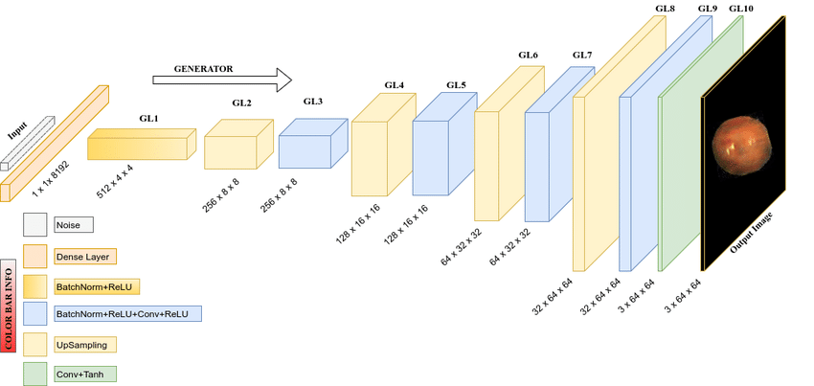

**Figure 4. Generator Architecture**

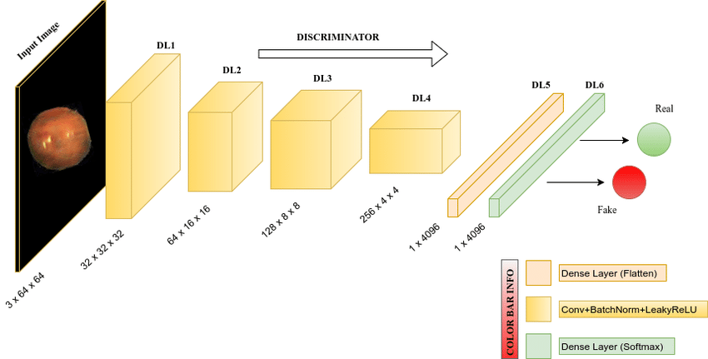

**Figure 5. Discriminator Architecture**

### GAN Used to Generate Leaves for Classification.

pix2pix uses a conditional generative adversarial network (cGAN) to learn a mapping from an input image to an output image.

The network is composed of two main pieces, the Generator and the Discriminator. The Generator applies some transform to the input image to get the output image. The Discriminator compares the input image to an unknown image (either a target image from the dataset or an output image from the generator) and tries to guess if the generator produced this.

An example of a dataset would be that the input image is a black and white picture and the target image is the color version of the picture.

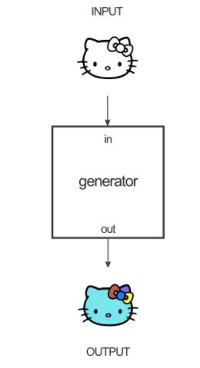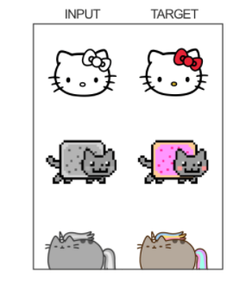

**Figure 6. . Input Dataset with Target**

**Figure 7. Generator trying to get colorize output**

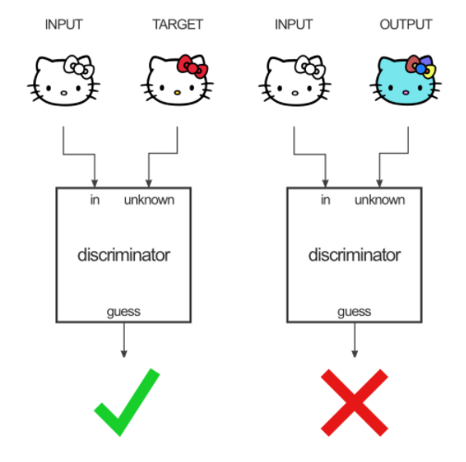

**Figure 8.The discriminator is looking at the generator's colorization attempts and trying to learn to tell the difference between the colorizations the generator provides, and the true colorized target image provided in the dataset.**

### Generator and Discriminator Architecture

**Generator**

The Generator has the job of taking an input image and performing the transform we want to produce the target image. An example input would be a black and white image, and we want the output to be a colorized version of that image. The structure of the generator is called an "encoder-decoder"

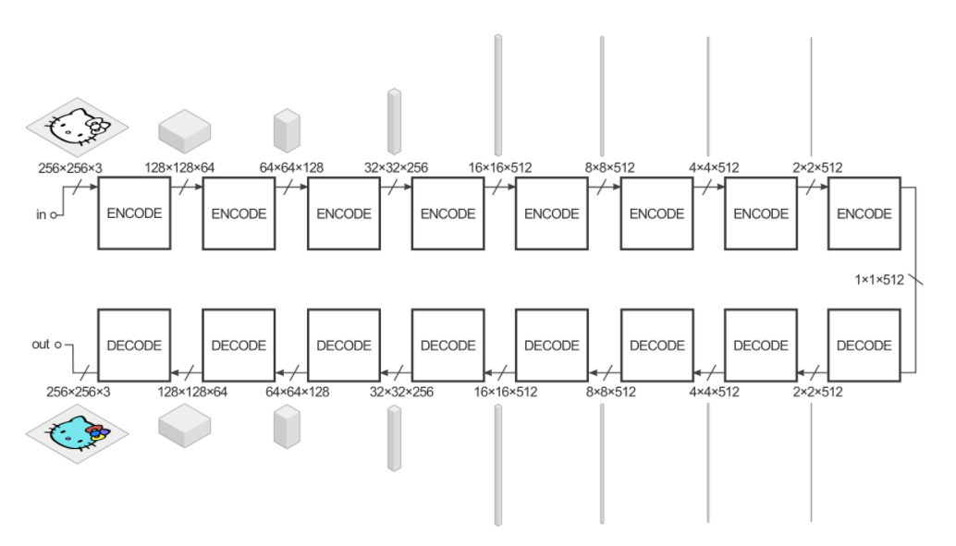

**Figure 9. Encoder-Decoder Structure**

The generator takes some input and tries to reduce it with a series of encoders (convolution + activation function) into a much smaller representation. The idea is that by compressing it this way we hopefully have a higher-level representation of the data after the final encode layer. The decode layers do the opposite (deconvolution + activation function) and reverse the action of the encoder layers.

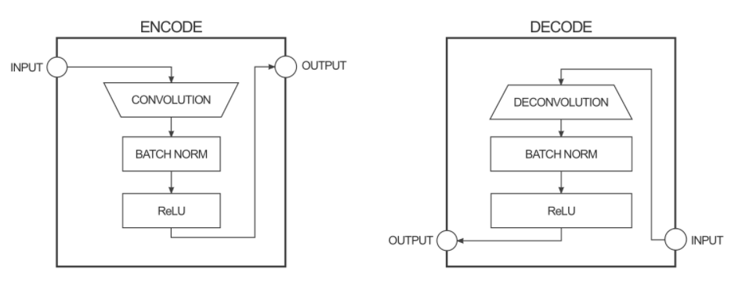

**Figure 10. Encode-Decode Operation**

To improve the performance of the image-to-image transform in the paper, the authors used a "U-Net" instead of an encoder-decoder. This is the same thing, but with "skip connections" directly connecting encoder layers to decoder layers.

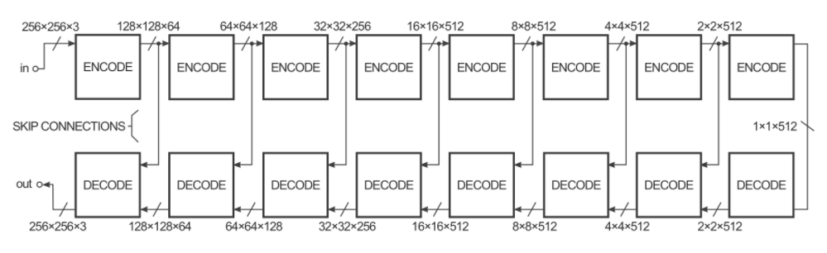

**Figure 11. U-net structure with skip Connections**

The skip connections give the network the option of bypassing the encoding/decoding part if it doesn't have a use for it. These diagrams are a slight simplification. For instance, the first and last layers of the network have no batch norm layer and a few layers in the middle have dropout units.

**Discriminator**

The Discriminator has the job of taking two images, an input image and an unknown image (which will be either a target or output image from the generator), and deciding if the second image was produced by the generator or not.

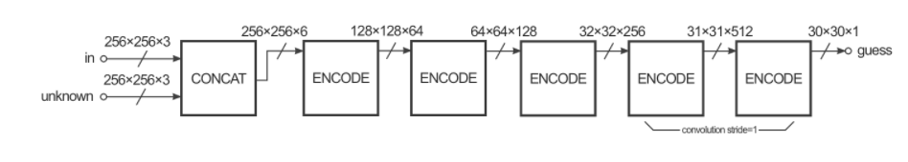

**Figure 12. Discriminator Structure**

The structure looks a lot like the encoder section of the generator, but works a little differently. The output is a 30x30 image where each pixel value (0 to 1) represents how believable the corresponding section of the unknown image is. In the pix2pix implementation, each pixel from this 30x30 image corresponds to the believability of a 70x70 patch of the input image (the patches overlap a lot since the input images are 256x256). The architecture is called a "PatchGAN".

**Training**

To train this network, there are two steps: training the discriminator and training the generator.

To train the discriminator, first the generator generates an output image. The discriminator looks at the input/target pair and the input/output pair and produces its guess about how realistic they look. The weights of the discriminator are then adjusted based on the classification error of the input/output pair and the input/target pair.

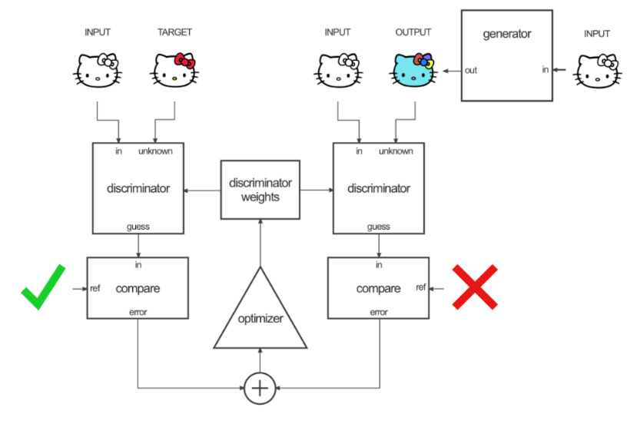

**Figure 13. Discriminator Training**

The generator's weights are then adjusted based on the output of the discriminator as well as the difference between the output and target image.

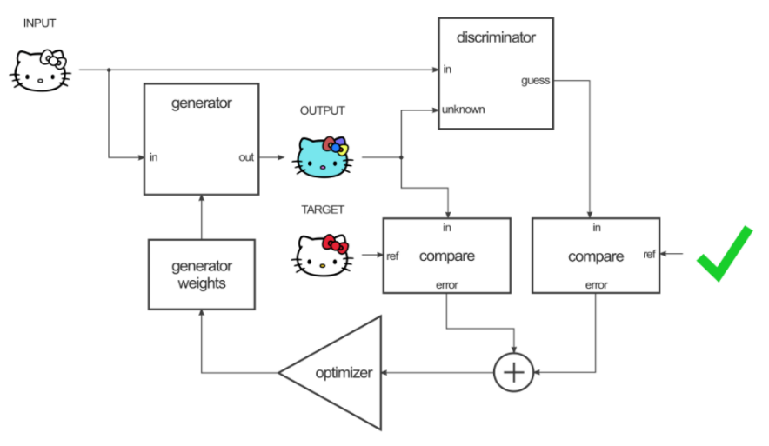

**Figure 14.Generator Training**

The clever trick here is that when you train the generator on the output of the discriminator, you're calculating the gradients through the discriminator, which means that while the discriminator improves, you're training the generator to beat the discriminator.

The theory is that as the discriminator gets better, so does the generator. If the discriminator is good at its job and the generator can learn the correct mapping function through gradient descent, you should get generated outputs that could fool a human.

## **Convolutional Neural Networks**

Convolutional Neural Networks (ConvNets or CNNs) are a category of Neural Networks that have proven very effective in areas such as image recognition and classification. ConvNets have been successful in identifying faces, objects and traffic signs apart from powering vision in robots and self driving cars.

LeNet was one of the very first convolutional neural networks which helped propel the field of Deep Learning. This pioneering work by Yann LeCun was named LeNet5 after many previous successful iterations since the year 1988. At that time the LeNet architecture was used mainly for character recognition tasks such as reading zip codes, digits, etc.

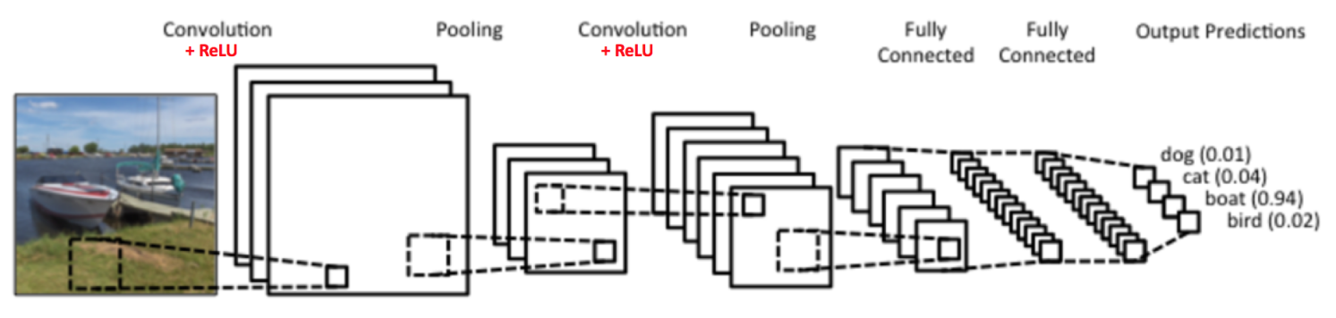

**Figure 15. A simple ConvNet.**

There are four main operations in the ConvNet shown above:

1. **Convolution**

ConvNets derive their name from the “convolution” operator. The primary purpose of Convolution in case of a ConvNet is to extract features from the input image. Convolution preserves the spatial relationship between pixels by learning image features using small squares of input data. In CNN terminology, the n×n matrix is called a ‘filter‘ or ‘kernel’ or ‘feature detector’ and the matrix formed by sliding the filter over the image and computing the dot product is called the ‘Convolved Feature’ or ‘Activation Map’ or the ‘Feature Map‘. It is important to note that filters acts as feature detectors from the original input image.

In the table below, we can see the effects of convolution of the above image with different filters. As shown, we can perform operations such as Edge Detection, Sharpen and Blur just by changing the numeric values of our filter matrix before the convolution operation [8] – this means that different filters can detect different features from an image, for example edges, curves etc.

**Table 1. Convolution filters and their respective outputs**

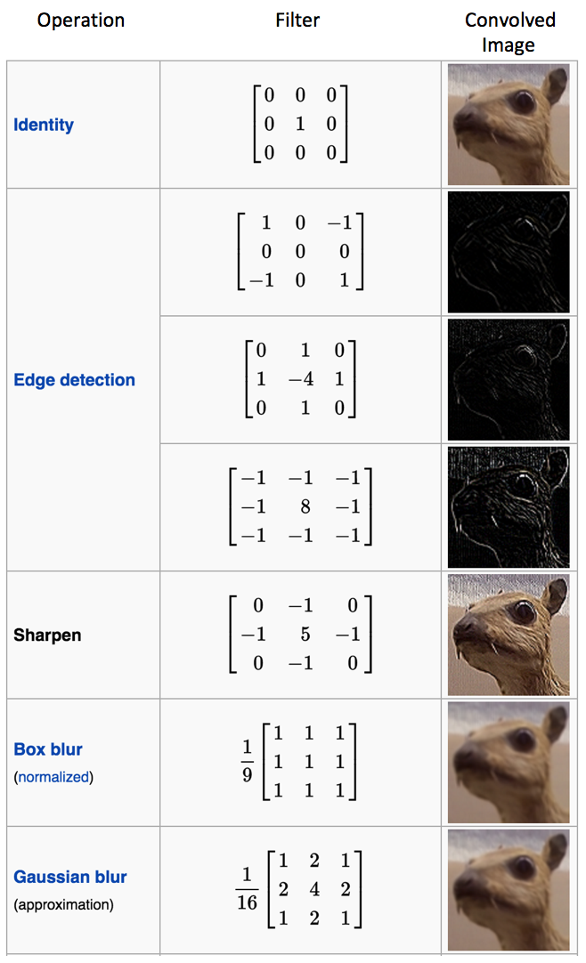

1. **Non Linearity (ReLU)**

An additional operation called ReLU has been used after every Convolution operation in Figure 3 above. ReLU stands for Rectified Linear Unit and is a non-linear operation. Its output is given by:

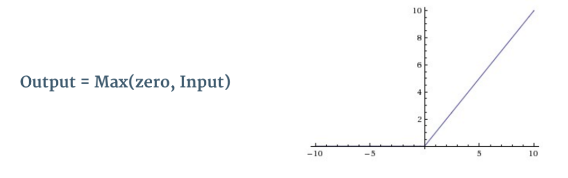

**Figure 16. the ReLU operation**

ReLU is an element wise operation (applied per pixel) and replaces all negative pixel values in the feature map by zero. The purpose of ReLU is to introduce non-linearity in our ConvNet, since most of the real-world data we would want our ConvNet to learn would be non-linear (Convolution is a linear operation – element wise matrix multiplication and addition, so we account for non-linearity by introducing a non-linear function like ReLU).

The ReLU operation can be understood clearly from Figure 9 below. It shows the ReLU operation applied to one of the feature maps obtained in Figure 6 above. The output feature map here is also referred to as the ‘Rectified’ feature map.

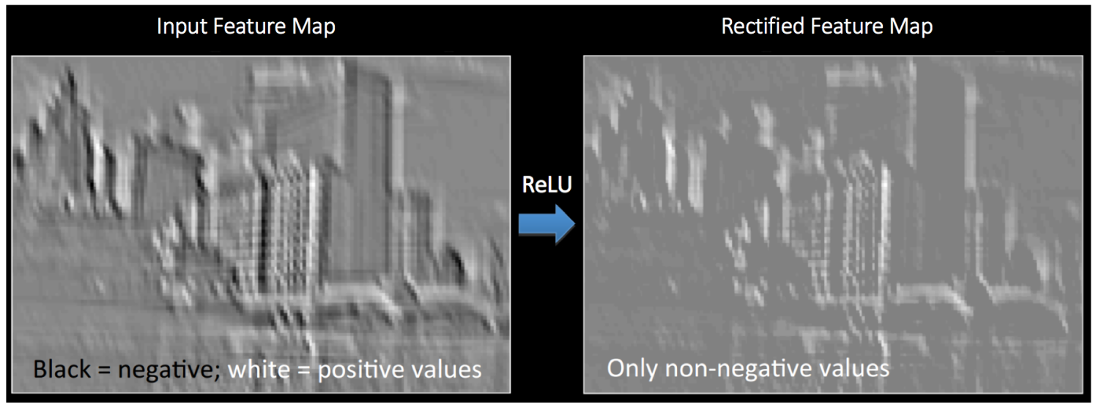

**Figure 17. ReLU operation.**

1. **Pooling or Sub Sampling**

Spatial Pooling (also called subsampling or downsampling) reduces the dimensionality of each feature map but retains the most important information. Spatial Pooling can be of different types: Max, Average, Sum etc.

In case of Max Pooling, we define a spatial neighborhood (for example, a 2×2 window) and take the largest element from the rectified feature map within that window. Instead of taking the largest element we could also take the average (Average Pooling) or sum of all elements in that window. In practice, Max Pooling has been shown to work better.

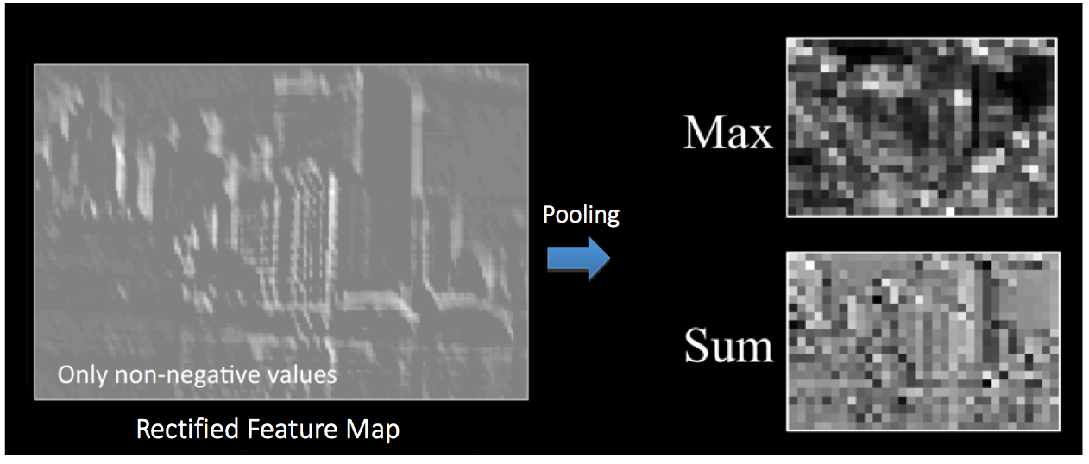

**Figure 18. Max Pooling**

1. **Classification (Fully Connected Layer)**

The output from the convolutional and pooling layers represent high-level features of the input image. The purpose of the Fully Connected layer is to use these features for classifying the input image into various classes based on the training dataset.

Apart from classification, adding a fully-connected layer is also a (usually) cheap way of learning non-linear combinations of these features. Most of the features from convolutional and pooling layers may be good for the classification task, but combinations of those features might be even better.

# **Methodology**

## **Dataset**

The dataset was created by taking images from Leafsnap, which, according to their website, is a series of electronic field guides being developed by researchers from Columbia University, the University of Maryland, and the Smithsonian Institution.  In the dataset it includes leaves from the Northeastern US and Canada, is comprised of 185 different species of trees.  Part of the dataset includes images of high quality taken from pressed leaves from the Smithsonian collection.  To create the dataset for this project, the lab quality images were selected and manually organised by common name.  Each species was examined to see which leaf form had a unique structure that both represented its genus, was significantly different from other genera, and was commonly found in this area.  Out of the 185 species, five genera were selected and overall there were 4,923 images in the dataset. Prior work noted leaf border as being a superior parameter when classifying leaf morphology (Kumar et al., 2012).  To explore this claim, the preprocessing included leaf border detection and vein extraction.

**Table 2. Description of dataset**

|  |  |
| --- | --- |
| **Genera** | **Number of Samples** |
| Elm | 932 |
| Magnolia | 880 |
| Maple | 995 |
| Oak | 1040 |
| Pine | 1076 |
| **Total** | **4923** |

## **Preprocessing**

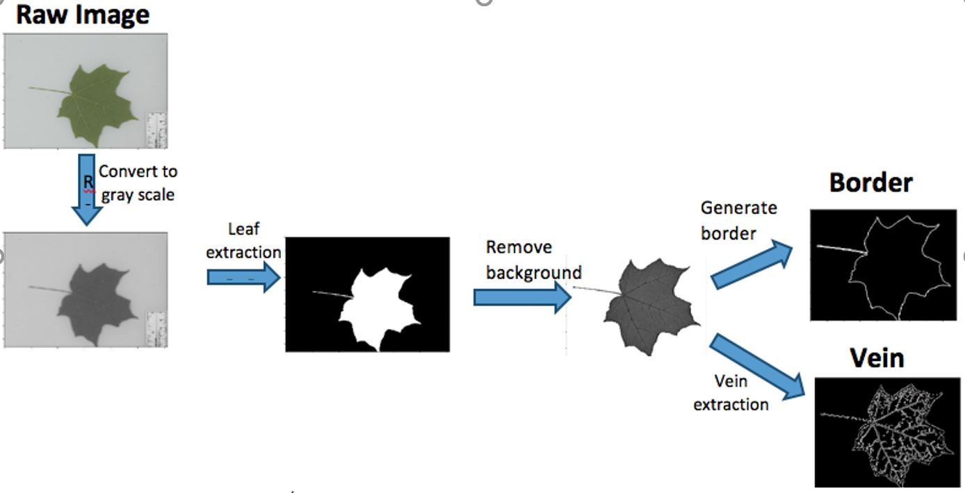

**Figure 19. Flow chart of image preprocessing**

To generate the hand-written leaves, we consider two common forms to simulate sketch images: border and vein. Border images only outline the shape of leaves while vein images delineate the exact fracture of leaves. The procedure of preprocessing is as follows:

1) Decolorize the raw image from RGB to gray image

2) Implement global thresholding on the gray image to generate the leaf mask

3) Cast the mask on gray scales image and remove the background

4) A. generate the border of leave

B. put a canny filter to extract the vein

## **GAN – Training and Validation**

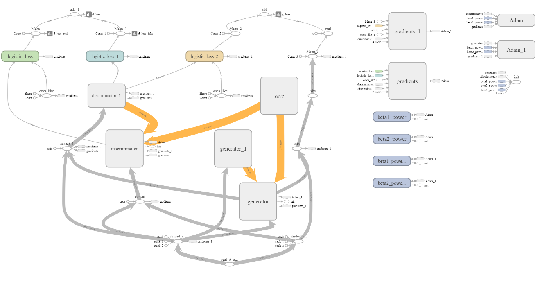

**Figure 20. Graph of GAN architecture (generated from tensorboard)**

The GAN training takes 4 days to run over 87 epochs for both.

### **D-Loss and G-Loss for Images with veins**

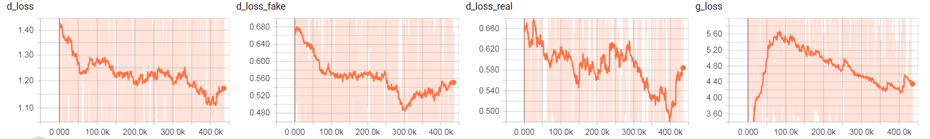

**Figure 21. Step**

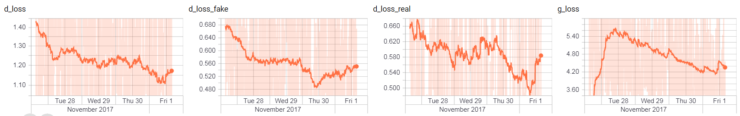

**Figure 22. Wall**

### **D-Loss and G-Loss with borders**

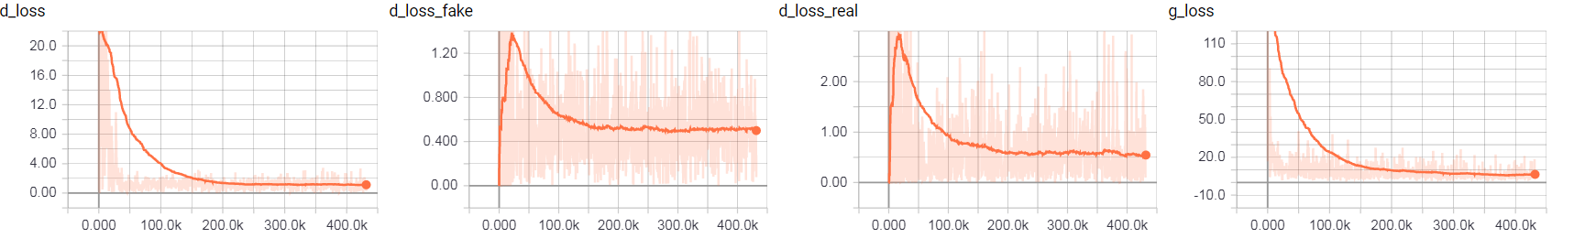

**Figure 23. Step**

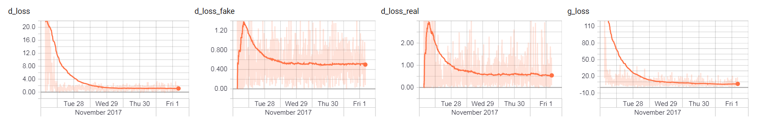

**Figure 24. Wall**

## **CNN – Training and Validation**

Alexnet is being used for classification of reconstructed leaves. This network has 5 convolutional layers, and 3 fully connected layers.

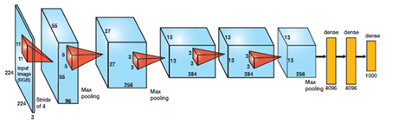

**Figure 25. Alexnet Architecture**

Classification is being used to estimate the reconstruction quality. Alexnet is trained on original leaf dataset, containing Elm, Magnolia, Maple, Pine and Oak leaves.



**Figure 26. Maple, Magnolia, Pine, Elm, Oak leaves (left to right)**

The classifier is tested on the reconstructed vein and border images generated by the GAN.

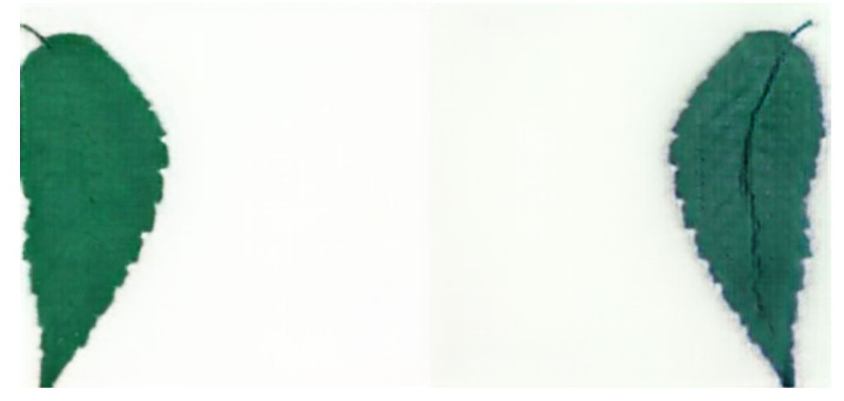

**Figure 27. Sample of reconstructed border and vein images (left to right)**

# **Results and Conclusion**

## **Results of GAN**



**Figure 28. Elm**



**Figure 29. Magnolia**



**Figure 30. Oak**



**Figure 31. Maple**



**Figure 32. Pine**

## **Results of CNN**

**Table 3. CNN Analysis**

|  |  |  |  |  |
| --- | --- | --- | --- | --- |
| Number of Training Images | Training Accuracy | Validation Accuracy | Testing Accuracy | |
| **Border** | **Vein** |
| 4923 | **92.85%** | **96.85%** | **87.14%** | **82.55%** |

**Table 4. Confusion Matrix for vein reconstructed images**

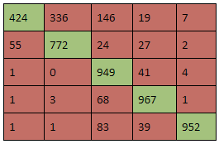

**Table 5. Confusion Matrix for border reconstructed images**

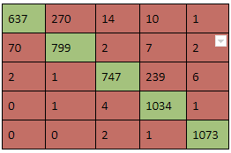

# **Future Work**

Future Work is highly dependent on testing these models for different applications. GAN is a very powerful tool which can be used to generate new images based on a given datsaet.

One can also add additional tree species to the selected genera to further diversify each class along with increasing the number of genera to encompass many other species. This method may also be applied to other elements to classify trees, such as adding bark texture and flowers. Furthermore, it can be applied to other elements of nature, from animal species to human faces.

# References

Isola, Phillip and Zhu, Jun-Yan and Zhou, Tinghui and Efros, Alexei A, “Image-to-Image Translation with Conditional Adversarial Networks”

Neeraj Kumar, Peter N. Belhumeur, Arijit Biswas, David W. Jacobs, W. John Kress, Ida Lopez, João V. B. Soares, "Leafsnap: A Computer Vision System for Automatic Plant Species”

Krizhevsky, Alex, Ilya Sutskever, and Geoffrey E. Hinton. "Imagenet classification with deep convolutional neural networks." Advances in neural information processing systems. 2012

[Scott Reed](https://arxiv.org/find/cs/1/au:+Reed_S/0/1/0/all/0/1), [Zeynep Akata](https://arxiv.org/find/cs/1/au:+Akata_Z/0/1/0/all/0/1), [Xinchen Yan](https://arxiv.org/find/cs/1/au:+Yan_X/0/1/0/all/0/1), [Lajanugen Logeswaran](https://arxiv.org/find/cs/1/au:+Logeswaran_L/0/1/0/all/0/1), [Bernt Schiele](https://arxiv.org/find/cs/1/au:+Schiele_B/0/1/0/all/0/1), [Honglak Lee](https://arxiv.org/find/cs/1/au:+Lee_H/0/1/0/all/0/1): Generative Adversarial Text to Image Synthesis

Ponce J. et al. (2006) Dataset Issues in Object Recognition. In: Ponce J., Hebert M., Schmid C., Zisserman A. (eds) Toward Category-Level Object Recognition. Lecture Notes in Computer Science, vol 4170. Springer, Berlin, Heidelberg

Agarwal, S., Roth, D.: Learning a sparse representation for object detection. In: Proc. European Conf. Comp. Vision. Volume LNCS 2353., Copenhagen, Denmark (2002) 113–127

Fei-Fei, L., Fergus, R., Perona, P.: Learning generative visual models from few training examples: an incremental Bayesian approach tested on 101 object categories. In: Proc. IEEE Conf. Comp. Vision Patt. Recog Workshop on GenerativeModel Based Vision. (2004)

Fergus, R., Perona, P., Zisserman, A.: Object class recognition by unsupervised scale-invariant learning. In: Proc. IEEE Conf. Comp. Vision Patt. Recog. Vol. II (2003) 264–271

Ji-Xiang Du, Xiao-Feng Wang, Guo-Jun Zhang, Leaf shape based plant species recognition, In Applied Mathematics and Computation, Volume 185, Issue 2, 2007, Pages 883-893, ISSN 0096-3003, https://doi.org/10.1016/j.amc.2006.07.072.

Shanwen Zhang, Yingke Lei, Tianbao Dong, Xiao-Ping Zhang, Label propagation based supervised locality projection analysis for plant leaf classification, In Pattern Recognition, Volume 46, Issue 7, 2013, Pages 1891-1897, ISSN 0031-3203, https://doi.org/10.1016/j.patcog.2013.01.015.

Wiseodd. “Wiseodd/Generative-Models.” GitHub, 28 Oct. 2017, github.com/wiseodd/generative-models.

Yenchenlin. “Yenchenlin/pix2pix-Tensorflow.” GitHub, 22 Mar. 2017, github.com/yenchenlin/pix2pix-tensorflow.

<https://blog.keras.io/building-powerful-image-classification-models-using-very-little-data.html>

<https://towardsdatascience.com/towards-data-set-augmentation-with-gans-9dd64e9628e6>

<https://papers.nips.cc/paper/5423-generative-adversarial-nets.pdf>

<http://blog.aylien.com/introduction-generative-adversarial-networks-code-tensorflow/>

<https://ishmaelbelghazi.github.io/ALI/>

<https://affinelayer.com/pix2pix/>

<https://www.oreilly.com/learning/generative-adversarial-networks-for-beginners/>

<https://www.sciencedirect.com/science/article/pii/S009630030600806X>

<http://www.sciencedirect.com/science/article/pii/S0031320313000502>

https://github.com/wiseodd/generative-models

https://github.com/yenchenlin/pix2pix-tensorflow